Bundle proximity losses in slot-bound conductors can become dominant contributors to the copper losses in high-speed ac machines, significantly reducing the machine efficiency. These proximity losses are a function of the slot geometry, wire current density, and frequency of the stator current. The bundle circulating currents are caused by induced voltages in the conductors that highly depend on the location of the conductors within the slot. The finite element magnetic field model along with the coupled circuit models that are used to predict these circulating currents are time consuming to solve due to the extremely large number of elements needed. In addition, the transposition (i.e., twisting) of bundles can only be captured using 3-D models. Some of these analyses reach up to 12 million elements and require up to 36 hours to run using a modern PC. The Condor distributed computation facility was used to solve these 3-D models in a highly efficient manner that is many times faster than conventional computing using a single high-speed PC. The analytical results have already been presented at the 2009 IEEE Energy Conversion Congress & Expo held in San Jose during Sept 12-16, 2009. Work is continuing to extend this investigation to the optimization of slot-bound winding configurations in order to minimize the bundle proximity losses by taking advantage of Condor’s special capabilities for highly parallelized computation.
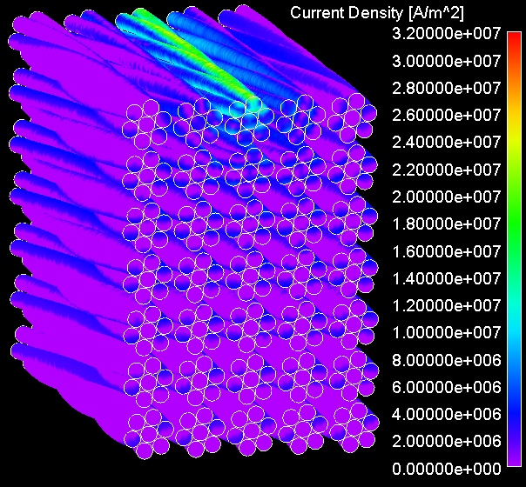 | 